3.Detailed Design:

This section provides detailed diagrams for some function:

1) Order: Allows the costumer to order and if there is any special order you can write it.

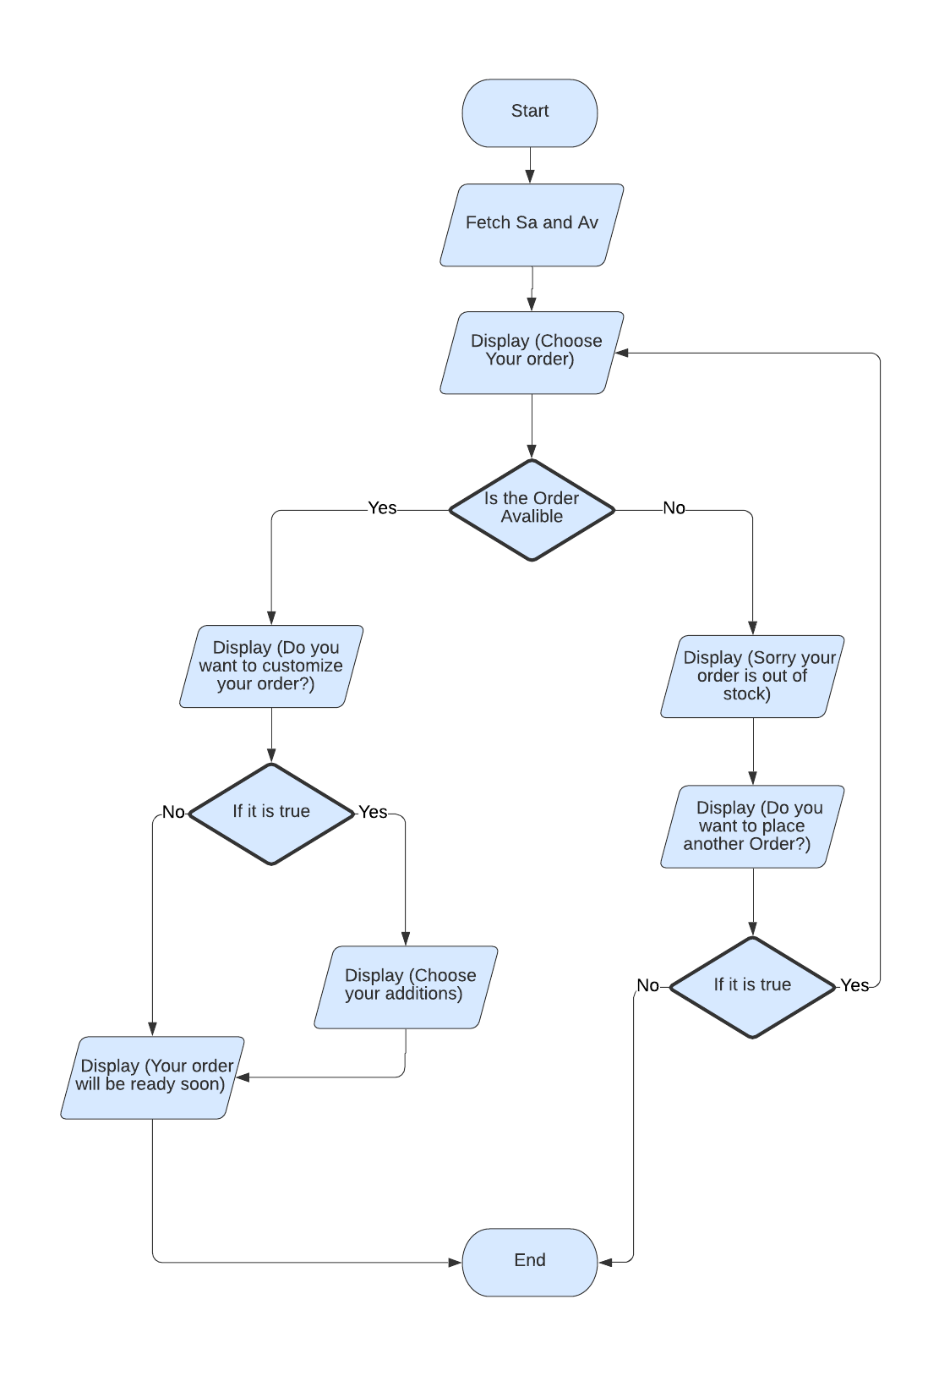

2) Payment: The payment process after finishing everything to check out .

